Digital Receipt Vault using Blockchain
And IPFS

Swetha G
IV Year CSE
Coimbatore Institute of Technology
Coimbatore-641014,India
Mrs. Revathy Manhoran
Assistant Professor
CoimbatoreInstitute of Technology
Coimbatore-641014,India

Sanjay S M
IV Year CSE
Coimbatore Institute of Technology
Coimbatore-641014,India
Sanjeev Singh Kaatal
IV Year CSE
Coimbatore Institute of Technology
Coimbatore-641014,India

Tamilselvan D
IV Year CSE
Coimbatore Institute of Technology
Coimbatore-641014,India

Abstract — In the proposed system, receipt files are uploaded by the issuer and stored in IPFS, which generates a unique Content Identifier (CID) based on the file’s cryptographic hash, ensuring data integrity and immutability. The issuer digitally signs the CID along with receipt metadata and generates a claimable link for the user. The user claims ownership by signing the receipt using their private key, and the signed transaction is permanently recorded on the Ethereum blockchain via a Solidity smart contract. The smart contract stores only essential metadata such as the CID, issuer and owner addresses, signatures, and timestamps, ensuring scalability and low on-chain storage cost.
Keywords —Blockchain, Metamask, , IPFS, CID, Smart Contract, Ethereum Sepolia, Solidity

Introduction
The rapid digitization of financial and official transactions has led to widespread use of digital receipts and documents. While digital formats improve accessibility and efficiency, they also introduce challenges related to security, authenticity, and trust. Traditional systems rely heavily on centralized databases and authorities for document issuance and verification, which makes them vulnerable to tampering, data breaches, and unauthorized access.

Blockchain technology, combined with decentralized storage and cryptographic techniques, offers a promising solution to address these issues by enabling immutable, transparent, and trustless document verification systems. To overcome these limitations, this project presents a decentralized and cryptographically secure digital receipt issuance and verification system using IPFS, blockchain technology, and public-key cryptography.

In the proposed system, receipt files are uploaded by the issuer and stored in IPFS, which generates a unique Content Identifier (CID) based on the file’s cryptographic hash, ensuring data integrity and immutability. The issuer digitally signs the CID along with receipt metadata and generates a claimable link for the user. The user claims ownership by signing the receipt using their private key, and the signed transaction is permanently recorded on the Ethereum blockchain via a Solidity smart contract.

Existing digital document management systems lack a reliable mechanism to guarantee document authenticity, immutability, and ownership. Centralized storage makes documents susceptible to tampering and unauthorized access. Verification depends on the issuing organization, resulting in delayed and unreliable third-party validation. There is no standardized, tamper-proof method to prove that a document was issued by a legitimate authority and has not been altered over time. There is a need for a decentralized and cryptographically secure system for document issuance and verification.

To design and implement a decentralized digital receipt and document verification system. To ensure immutability and integrity of documents using blockchain and content addressed storage. To enable cryptographic proof of ownership through digital signatures. To support trustless third-party verification without dependence on centralized authorities. To provide a scalable and cost-efficient solution by storing only essential metadata on-chain.

The proposed solution follows a layered architecture consisting of application, backend, storage, and blockchain layers. Receipt files are uploaded by the issuer and stored in IPFS, which generates a unique Content Identifier (CID) based on the file’s cryptographic hash. The issuer digitally signs the CID and receipt metadata, and a claimable link is generated for the user. The user claims ownership by signing the receipt, and the transaction is recorded on the Ethereum blockchain using a Solidity smart contract. The smart contract stores metadata such as the CID, issuer address, owner address, cryptographic signatures, and timestamps. Verification is performed by deriving public keys from stored signatures, enabling secure and trustless validation.

Applicable to digital receipts, invoices, certificates, and official documents. Supports public verification without revealing sensitive document content. Eliminates document forgery and unauthorized modification through immutability. Can be extended to support NFT-based ownership, multi-signature verification, or privacy-enhancing techniques. Suitable for use in finance, education, healthcare, legal systems, and e-governance platforms.

LITERATURE SURVEY
The literature survey indicates a strong preference for hybrid blockchain architectures that combine on-chain and off-chain storage mechanisms. Most of the reviewed studies utilize decentralized storage platforms such as IPFS to store large files, while maintaining cryptographic hashes, metadata, and ownership records on the blockchain. This architectural choice effectively addresses the limitations of blockchain storage, such as high cost and low scalability, while preserving data integrity and immutability. The use of content-based addressing in IPFS ensures that any modification to stored data can be easily detected through hash mismatches, thereby enhancing trust and reliability in digital document and receipt management systems.

Another significant finding is the extensive use of smart contracts to automate trust and verification processes. Smart contracts are employed to manage critical operations including receipt issuance, ownership transfer, access control, and fair delivery of digital assets. By encoding verification logic directly into smart contracts, these systems eliminate the need for centralized intermediaries and reduce human intervention. The literature demonstrates that smart contract–based solutions provide transparency, non-repudiation, and deterministic execution, making them particularly suitable for applications involving legal documents, supply chain receipts, and multi-party agreements.
Security considerations form a central theme across all surveyed papers. The reviewed works consistently integrate cryptographic mechanisms such as digital signatures, hash functions, elliptic curve cryptography, and encryption schemes to ensure confidentiality, authenticity, and integrity of data. These techniques are used to verify user identity, protect sensitive information, and prevent unauthorized modifications. When combined with the immutable nature of blockchain, cryptographic security mechanisms significantly reduce the risks of forgery, tampering, and fraud in decentralized systems.
Finally, the literature highlights an increasing focus on scalability, performance optimization, and practical deployment challenges. To overcome blockchain latency and throughput limitations, several studies introduce middleware layers, off-chain computation, and cross-chain communication mechanisms. These approaches improve system efficiency and enable the deployment of blockchain-based verification systems in complex real-world environments such as supply chains and social data platforms.

S. No | Title | Year | Methodology | Key Inference
1 | An integrated blockchain and IPFS-based solution for secure and efficient source code repository hosting using middleman approach [3] | 2025 | Hybrid architecture using IPFS for off-chain storage, Ethereum smart contracts for hash verification, and a middleware layer for encryption and CID handling. | Improves storage efficiency and upload performance while maintaining secure, tamper-proof version control.
2 | A Security-Oriented Data-Sharing Scheme Based on Blockchain [2] | 2024 | Blockchain-based data sharing using smart contracts, ECC encryption, and digital sigfnatures | Ensures secure, controlled data sharing with strong integrity and confidentiality guarantees.
3 | A cross-chain model for warehouse receipts in port supply chain based on notary mechanism and ShangMi cryptographic algorithms [1] | 2025 | Cross-chain blockchain framework with notary mechanism and ShangMi cryptographic algorithms for receipt validation and transfer. | Enables secure, scalable, and interoperable warehouse receipt management across multiple blockchains.
4 | A Blockchain-Based Protocol for Fair Delivery for Receipts [4] | 2024 | Smart contract–based fair exchange protocol using cryptographic commitments and digital signatures. | Guarantees fair receipt delivery with non-repudiation and no reliance on trusted third parties.

Table 2.1. Findings from the research papers studied

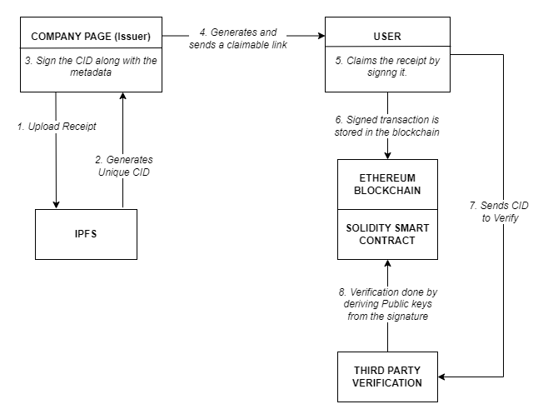

Figure 3.1:Cryptographic Flow

METHODOLOGY
The proposed system presents a decentralized and secure framework for issuing, managing, and verifying digital receipts by integrating decentralized storage, cryptographic authentication, and blockchain-based verification mechanisms. The methodology is designed to overcome the limitations of traditional centralized receipt management systems, such as data tampering, lack of transparency, and dependency on trusted intermediaries. The system adopts a hybrid architecture that combines off-chain storage using the InterPlanetary File System (IPFS) with on-chain verification using the Ethereum blockchain, ensuring data integrity, authenticity, non-repudiation, and scalability.
The process begins when the issuer interacts with the system through the company interface to upload a digital receipt, such as an invoice or warranty document. This receipt is forwarded to the backend component, which is responsible for handling file processing and communication with external services. The backend uploads the receipt to IPFS, where the file is stored in a distributed and content-addressed manner. Upon successful upload, IPFS generates a unique Content Identifier (CID) derived from the cryptographic hash of the receipt. This CID uniquely represents the exact content of the receipt, and any modification to the file results in a different CID, thereby ensuring immutability and integrity of the stored data without requiring on-chain storage of large files.
Once the CID is generated, it is returned to the backend and forwarded to the issuer. The issuer digitally signs the CID along with associated metadata such as receipt hash and issuance timestamp using its private key. This digital signature establishes cryptographic proof that the receipt was legitimately issued by the company and has not been altered since issuance. The signed CID serves as a secure reference to the receipt stored in IPFS and enables later verification without exposing the actual receipt content on the blockchain. After signing, the backend generates a claimable link embedding the signed CID. This link is securely transmitted to the intended recipient via an integrated email service, ensuring controlled and traceable distribution of the receipt.
The recipient accesses the claimable link through the user interface and initiates the receipt claim process. During this step, the user verifies the receipt information and digitally signs the CID using their private key, typically through a wallet-based signing mechanism. This user signature cryptographically binds the receipt to the user’s blockchain address, establishing ownership while preserving privacy. No personal or sensitive user information is stored on-chain, as ownership is represented solely by the blockchain address associated with the user’s signature. The signed payload, containing the CID, issuer signature, and user signature, is then submitted to the blockchain network as a transaction.
The blockchain layer consists of a Solidity smart contract deployed on the Ethereum network, which acts as the core trust enforcement mechanism. Upon receiving the transaction, the smart contract verifies both the issuer’s and

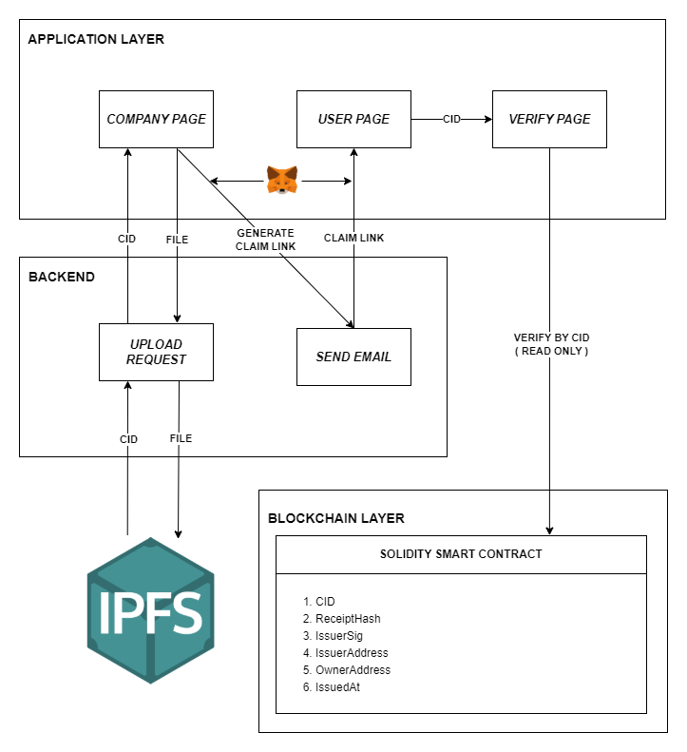

Figure 3.2:System Architecture

user’s signatures using public-key cryptography. Only transactions that successfully pass these verification checks are accepted. The smart contract then records essential receipt metadata on-chain, including the CID, receipt hash, issuer signature, issuer address, owner address, and issuance timestamp. Storing only cryptographic references rather than the actual receipt file ensures cost efficiency, scalability, and reduced gas consumption. The blockchain record provides an immutable and timestamped proof of receipt issuance and ownership, which can be used for audit, dispute resolution, and long-term verification.
For verification purposes, the system allows third parties to validate receipts without requiring permission from the issuer or owner. A verifier submits the CID through the verification interface, which triggers a read-only call to the smart contract. This verification process does not modify the blockchain state and therefore incurs no transaction cost. The smart contract retrieves the stored metadata and validates the receipt by deriving public keys from the stored digital signatures and matching them against the issuer and owner addresses. Successful verification confirms that the receipt was issued by a legitimate issuer, has not been tampered with, and is currently owned by the claimed user. The verifier can additionally retrieve the receipt directly from IPFS using the CID and compare its hash with the on-chain reference, enabling complete transparency and trustless verification.
Throughout the methodology, the separation of responsibilities across application, backend, and blockchain components improves modularity, security, and maintainability. The backend layer simplifies interactions between users, IPFS, and the blockchain, while the blockchain layer ensures immutable trust guarantees. The use of IPFS for off-chain storage significantly reduces the storage and computational burden on the blockchain, making the system suitable for real-world deployment at scale. By combining decentralized storage, cryptographic signatures, and blockchain immutability, the proposed methodology provides a robust, scalable, and transparent solution for digital receipt issuance and verification in applications such as warranty management, audit systems, and document authentication.

RESULTS AND DISCUSSIONS

CONCLUSION

References

- Chen Y, Ou W, Pang M, Ma J, Yue Q, Han W. A cross-chain model for warehouse receipts in port supply chain based on notary mechanism and ShangMi cryptographic algorithms. Sci Rep. 2025 Apr 24;15(1):14390. doi: 10.1038/s41598-025-99611-7. PMID: 40274998; PMCID: PMC12022273\

- Ma, W.; Wei, X.; Wang, L. A Security-Oriented Data-Sharing Scheme Based on Blockchain. Appl. Sci. 2024, 14, 6940. https://doi.org/10.3390/app14166940

- Haque MR, Islam Munna S, Ahmed S, Islam MT, Hassan Onik MM, Rahman AA (2025) An integrated blockchain and IPFS-based solution for secure and efficient source code repository hosting using middleman approach. PLoS One 20(9): e0331131. https://doi.org/10.1371/journal.pone.0331131

- Parab, Aishwarya, et al. "A Blockchain-Enabled Framework for Storage and Retrieval of Social Data." arXiv preprint arXiv:2503.20497 (2025).

- Hinarejos, M.F.; Ferrer-Gomila, J.-L.; Isern-Deyà, A.-P.; Chévez-Alvarado, G.-F. A Blockchain-Based Protocol for Fair Delivery for Receipts. Future Internet 2025, 17, 5. https://doi.org/10.3390/fi17010005

- Jiang, R., Li, Y., Pu, X. et al. A fair multi-party contract signing scheme based on off-chain protocols and on-chain smart contracts. J Supercomput 81, 372 (2025). https://doi.org/10.1007/s11227-024-06844-w

